Food
A “build your own” strategy is often helpful when kids have strong food aversions, or when they need more hands-on control of what goes on their plates. These Baked Nachos are an easy crowd-pleaser that can even be made in individual portions.

BUILD YOUR OWN BAKED NACHOS

Team Member Bri says her teen and tween boys love to see baked nachos on the dinner table. “We don’t really use a recipe so much as a method,” she says. “Sometimes we make them with leftover cooked chicken, sometimes we use taco meat, and sometimes it’s just beans or veggies. We kind of like to toss on whatever’s in the fridge that might work. It’s a great way to use up odds and ends!” To serve the nachos, she just puts the sheet pan on heatproof pads in the middle of the dinner table, and the family sits around the tray, snacking and chatting.

INGREDIENTS
Serves 6
- 1 bag (about 12 oz) tortilla chips of your choosing
- 4 green onions, diced
- 2 medium tomatoes, diced
- 1/2 medium bell pepper of any color, diced
- Additional toppings of your choice: Cooked diced or shredded chicken, pulled pork, taco meat, black beans, refried beans, corn kernels, jalapenos…you’re only limited by your imagination!
- 8 ounces shredded Cheddar Jack cheese
- 1/3 cup chopped cilantro
- 2 cups shredded romaine or iceberg lettuce
- 2 avocados, diced
- Salsa and sour cream, for serving

INSTRUCTIONS
- Preheat oven to 400 degrees.
- Spread out tortilla chips in an even layer on a rimmed baking sheet.
- Top the chips with the sliced green onions, diced tomatoes, peppers, and any other vegetables, meat or beans you’ve chosen.
- Finish assembling the nachos by adding an even layer of shredded cheese over the top. Bake the nachos at 400 degrees for about 10-15 minutes, until the cheese is melted and the chips are extra crispy around the edges.
- Top the baked nachos with the chopped cilantro, shredded lettuce and avocado before serving. Provide salsa or sour cream on the side for dipping!

Fun
Help wiggly kids take movement breaks while staying engaged at mealtimes with a round of “Waiter, Waiter!”

WAITER, WAITER

Contributed by The Family Dinner Project Team
The Waiter, Waiter! game helps give structured chances for family members to move away from the dinner table — and move back. Sometimes, family members need short breaks from sitting and participating in the meal. Kids who get fidgety after a short length of time, but still want to finish eating and being a part of the fun and conversation, might need an outlet that helps them move around without disrupting mealtime.
This game is also great for building additional skills, like listening, following directions, and gaining confidence with simple activities of daily living. Here’s how it works:
- You’ll need a way to keep track of time and/or signal that it’s time for the “waiter.” Use an alarm on a phone or watch or keep a bell or buzzer on the table.
- At intervals throughout your meal, ring the bell (or set the alarm to go off) to signal that it’s time for your child to get ready to help. You might decide to set an alarm for every 5 minutes throughout your meal, or simply ring the bell whenever you notice that someone is getting especially fidgety. It’s entirely up to you.
- When the bell or alarm has sounded, cry “Waiter, Waiter!” Then follow it up with a request for help that allows the child to leave the table to complete a task. For example:
  - “Waiter, waiter! Please bring more water to the table!”
  - “Waiter, waiter! We need more napkins, please!”
  - “Waiter, waiter! I spilled some sauce. Can you please bring a rag?”
  - “Waiter, waiter! Please bring us some ketchup!”
- Once your child has completed the task, make sure to say a big thank you before they sit back down.
You can change the name of the game if you like — “Helper, helper!” works just as well, or anything else you might prefer. It’s just about having a fun way to signal your child that they’re about to receive a task.

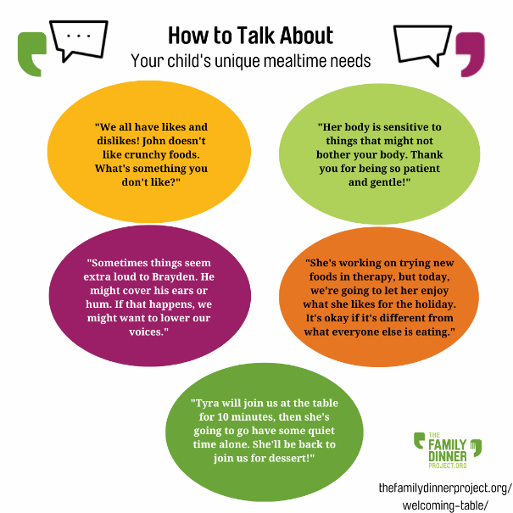
CONVERSATION
It can be hard to know how to talk about your child’s needs, especially in social settings. Here are some ideas to get the conversation started.

How can meals be comfortable and enjoyable for everyone?

When my older son was a toddler, he was a generally adventurous eater with a good appetite. People commented on his love for strong flavors like salmon and ginger, and his willingness to eat different foods. But as his parents, we noticed another side to his eating habits: His resistance to eating most fruits, the way he gagged when someone opened a yogurt container near him, the tears and tantrums when we served him cheese or strawberries. We also saw him go into full-blown panic mode if we tried to have him help with “kid-friendly” cooking tasks like pushing the button on the smoothie blender or kneading sticky bread dough.  Sound familiar? My kid, like many others, has sensory processing issues.  He’s now 16 years old, and we know that his sensory difficulties are linked to a neurological disorder that also causes some learning challenges and visual-motor problems. He’s also a confident, bright, talented guy who’s developed plenty of strong coping mechanisms over the years. | It’s sometimes hard for me to remember that at one point in time, his auditory sensitivities made family gatherings loud and uncomfortable for him, or that he might throw up at the smell of a banana or the feel of messy foods on his fingers. But when I do remember, I can vividly recall the accommodations we made to help him feel more comfortable in a variety of situations, including at family meals. I especially remember how challenging it was to help him feel safe, and to help others understand his sensory, motor, and social-emotional needs.  That’s why I’m so excited to reveal The Family Dinner Project’s newest initiative: The Welcoming Table. With support from the Tower Foundation and help from a panel of experts in neurodiversity, dietetics, special education, child psychiatry and psychology, occupational and feeding therapy, and trauma-informed care, we’ve created a new section of our website just for families whose mealtime needs go beyond the challenges of feeding typically developing kids.

